

**Bean Scopes**

**Bean Instance created by Spring Container can be in one of the following Scopes(Updated from Spring5).**

* 1. **singleton**
  2. **prototype**
  3. **request**
  4. **session**
  5. **application**
  6. **websocket**



**Scope** **Description**

**singleton** **When bean scope is singleton then only one instance will be created for that bean and the same instance will be returned when you call getBean() method.**

**singleton is the default scope in the ApplicationContext container. When scope is single-ton then default loading type is aggressive**

**loading.**

**prototype** **When bean scope is prototype then every time a new instance will be created for that bean when you call getBean() method.**

**When scope is prototype then default loading type is lazy loading.**

**request** **Scopes a single bean definition to the lifecycle of a single HTTP request.**

**Single Bean instance will be created per HTTP Request**

**Only valid in the context of a web-aware Spring ApplicationContext.**

**session** **Scopes a single bean definition to the lifecycle of an HTTP Session.**

**Single Bean instance will be created per HTTP Session**

**Only valid in the context of a web-aware Spring ApplicationContext.**

**application** **Scopes a single bean definition to the lifecycle of a ServletContext.**

**Single Bean instance will be created per ServletContext.**

**Only valid in the context of a web-aware Spring ApplicationContext.**

**websocket** **Scopes a single bean definition to the lifecycle of a WebSocket.**

**Single Bean instance will be created per WebSocket.**

**Only valid in the context of a web-aware Spring ApplicationContext.**

**Usage:**

**@Scope(value="singleton")**

**@Scope(value=" prototype ")**

**@Scope("singleton")**

**@Scope("prototype")**



**www.coursecube.com** **8** **Spring-5 Study Guide**



**Bean Scope Example with Java Configuration**



**Lab2: Files required**



|  |  |  |  |  |
| --- | --- | --- | --- | --- |
| **1.** | **Lab2.java** | **2.** | | **Hello.java** |
|  |  |  |  |  |
| **3.** | **Hai.java** | **4.** | | **JLCAppConfig.java** |
|  |  |  |  |  |



**1. Lab2.java**

**package com.coursecube.spring;**

**import org.springframework.context.ApplicationContext;**

**import org.springframework.context.annotation.AnnotationConfigApplicationContext; /\***

* **@Author : Srinivas Dande**
* **@Company : CourseCube**
* **@Website : www.coursecube.com**
* **\*/**

**public class Lab2 {**

**public static void main(String[] args) {**

**ApplicationContext ctx=new AnnotationConfigApplicationContext(JLCAppConfig.class); System.out.println("---------Now Spring Container is Ready-----");**

**Hello hello1=(Hello)ctx.getBean("hello");**

**Hello hello2=(Hello)ctx.getBean("hello");**

**System.out.println(hello1==hello2);**

**Hai hai1=(Hai)ctx.getBean("hai");**

**Hai hai2=(Hai)ctx.getBean("hai");**

**System.out.println(hai1==hai2);**

**Hello hello=(Hello)ctx.getBean("hello");**

**hello.showHello();**

**Hai hai=(Hai)ctx.getBean("hai");**

**hai.showHai();**

**}**

**}**



**2. Hello.java**

**package com.coursecube.spring;**

**/\***

* **@Author : Srinivas Dande**
* **@Company : CourseCube**
* **@Website : www.coursecube.com**
* **\*/**

**public class Hello {**

**static {**



**www.coursecube.com** **9** **Spring-5 Study Guide**

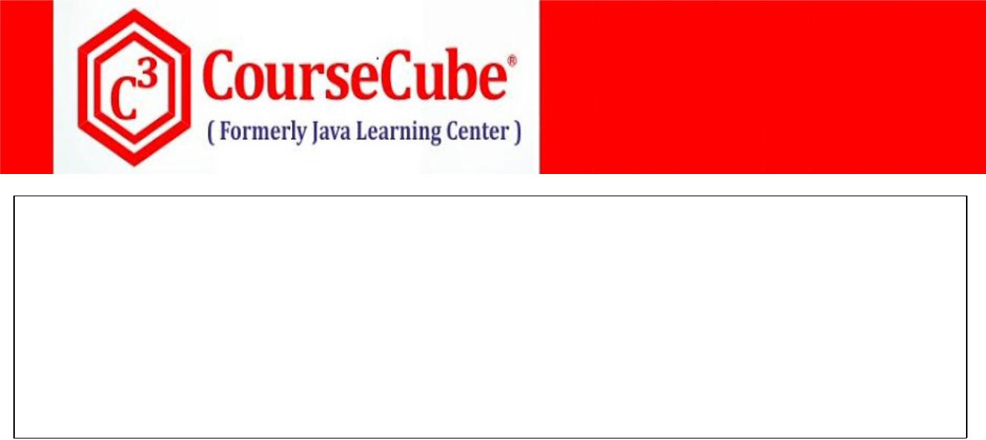

**System.out.println("Hello - S.B");**

**}**

**public Hello() {**

**System.out.println("Hello - D.C");**

**}**

**public void showHello() { System.out.println("Hello-showHello()");**

**}**

**}**



**3. Hai.java**

**package com.coursecube.spring;**

**/\***

* **@Author : Srinivas Dande**
* **@Company : CourseCube**
* **@Website : www.coursecube.com**
* **\*/**

**public class Hai {**

**static {**

**System.out.println("Hai - S.B");**

**}**

**public Hai() {**

**System.out.println("Hai - D.C");**

**}**

**public void showHai() {**

**System.out.println("Hai-showHai()");**

**}**

**}**



1. **JLCAppConfig.java package com.coursecube.spring;**

**import org.springframework.context.annotation.Bean;**

**import org.springframework.context.annotation.Configuration; import org.springframework.context.annotation.Scope; /\***

* **@Author : Srinivas Dande**
* **@Company : CourseCube**
* **@Website : www.coursecube.com**
* **\*/**

**@Configuration**

**public class JLCAppConfig {**

**@Bean("hello")**

**@Scope("singleton")**

**public Hello createHello() {**

**System.out.println("-------createHello() ------ called");**



**www.coursecube.com** **10** **Spring-5 Study Guide**

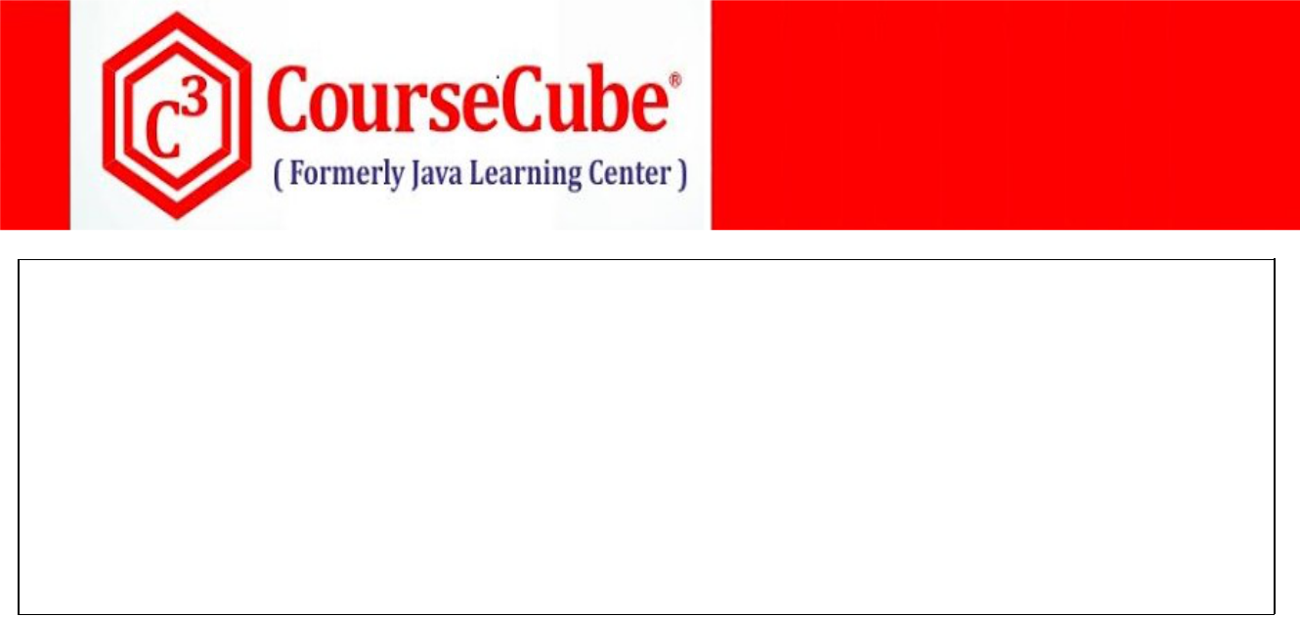

**return new Hello();**

**}**

**@Bean("hai")**

**@Scope("prototype")**

**public Hai createHai() {**

**System.out.println("-------createHai() ------ called");**

**return new Hai();**

**}**

**}**



**Bean Loading Types**

**Bean configured in the Spring Configuration Class can be loaded in two ways.**

* 1. **Aggressive loading or Eager loading**
  2. **Lazy loading.**

**Usage:**

**@Lazy(value="true")**

**@Lazy(value="true")**

**@Lazy("true")**

**@Lazy("false")**

1. **Aggressive loading or Eager loading**

**In the case of aggressive loading, all the Beans will be loaded, instantiated and initialized by the container at the container start-up.**



**Ex:**

**@Bean**

**@Lazy(false)**

**public Hello hello() {**

**return new Hello();**

**}**

1. **Lazy loading.**

**In the case of lazy loading, all the Beans will be loaded, instantiated and initialized when you or container try to use them by calling getBean() method.**



**Ex:**

**@Bean**

**@Lazy(true)**

**public Hello hello() {**

**return new Hello();**

**}**



**www.coursecube.com** **11** **Spring-5 Study Guide**



**Bean Loading Types Example with Java Configuration:**



**Lab3: Files required**



|  |  |  |
| --- | --- | --- |
| **1.** | **Lab3.java** | **New One** |
|  |  |  |
| **2.** | **Hello.java** | **Same as Lab2** |
|  |  |  |
| **3.** | **Hai.java** | **Same as Lab2** |
|  |  |  |
| **4.** | **JLCAppConfig.java** | **New One** |
|  |  |  |



**1. Lab3.java**

**package com.coursecube.spring;**

**import org.springframework.context.ApplicationContext;**

**import org.springframework.context.annotation.AnnotationConfigApplicationContext; /\***

* **@Author : Srinivas Dande**
* **@Company : CourseCube**
* **@Website : www.coursecube.com**
* **\*/**

**public class Lab3 {**

**public static void main(String[] args) {**

**ApplicationContext ctx=new AnnotationConfigApplicationContext(JLCAppConfig.class); System.out.println("---------Now Spring Container is Ready-----");**

**Hello hello=(Hello)ctx.getBean("hello");**

**hello.showHello();**

**Hai hai=(Hai)ctx.getBean("hai");**

**hai.showHai();**

**}**

**}**



1. **JLCAppConfig.java package com.coursecube.spring;**

**import org.springframework.context.annotation.Bean;**

**import org.springframework.context.annotation.Configuration; import org.springframework.context.annotation.Lazy; import org.springframework.context.annotation.Scope; /\***

* **@Author : Srinivas Dande**
* **@Company : CourseCube**
* **@Website : www.coursecube.com**
* **\*/**



**www.coursecube.com** **12** **Spring-5 Study Guide**

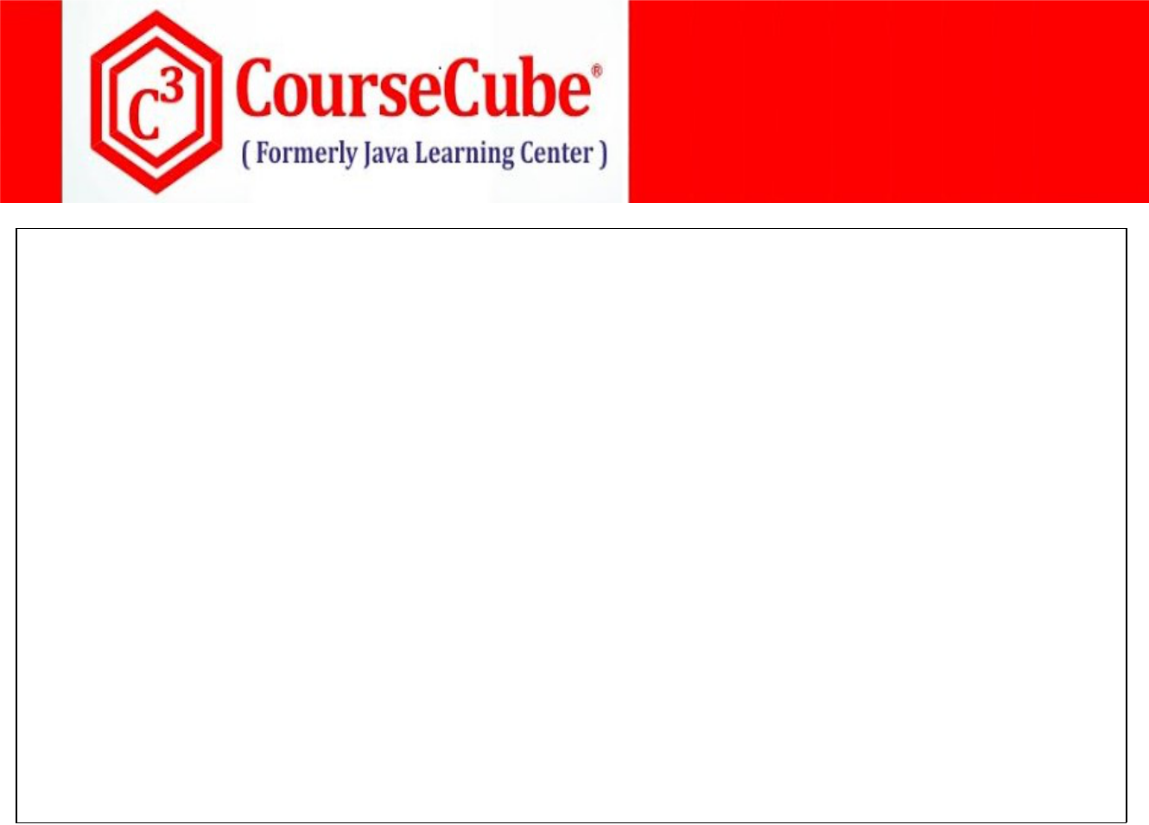

**@Configuration**

**public class JLCAppConfig {**

**@Bean("hello")**

**@Scope("singleton")**

**@Lazy(true)**

**public Hello createHello() {**

**System.out.println("-------createHello() ------ called");**

**return new Hello();**

**}**

**@Bean("hai")**

**@Scope("prototype")**

**@Lazy(true)**

**public Hai createHai() {**

**System.out.println("-------createHai() ------ called");**

**return new Hai();**

**}**

**}**



**www.coursecube.com** **13** **Spring-5 Study Guide**